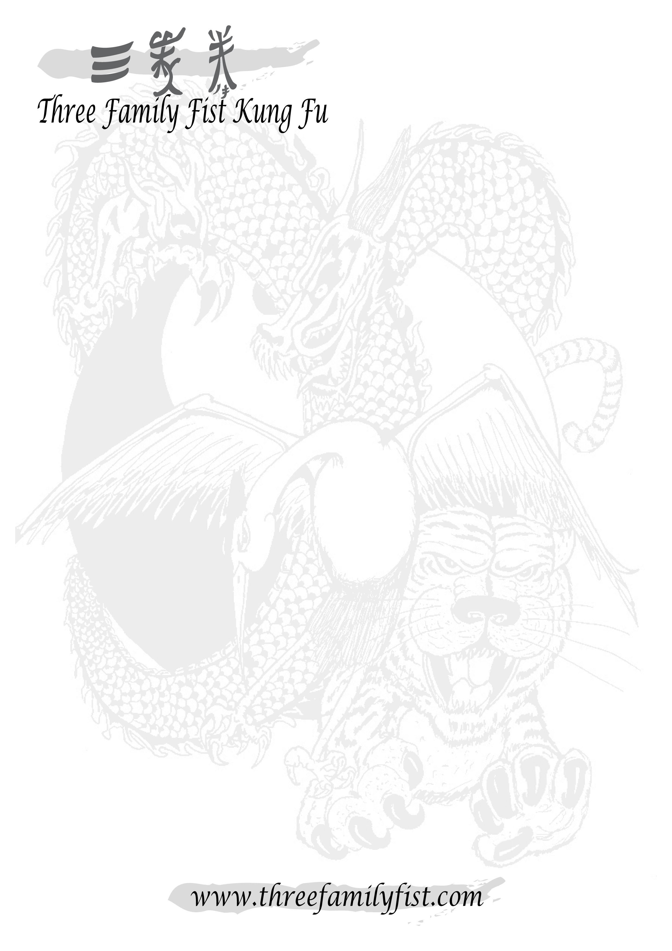
Dear student,
It is my pleasure to welcome you to the Three Family Fist system and thank you for choosing to train in our style of Kung Fu.
As part of our ongoing commitment to being the region’s most cost-effective martial arts, I would like to take this opportunity to make you aware of the fees required to continue our high standards of fun, safe tuition:
- Class fee: £6.00 per 1 hour 30 minute session.
- Membership fee: £35.00 – this fee is paid yearly.
- Kung Fu suits: £40.00 for a black printed tee and satin, embroidered trousers.
(Garments are sold separately – Tee: £18.00, Trousers: £25.00)
PLEASE NOTE: Membership and a suit are required before you can take your first grading.
- Grading fees: £25.00 for Yellow to Red sash levels.
£35.00 for Red to Blue sash levels.
£45.00 for Grey sash level.
£30.00 for each Black Tab sash levels.
£150.00 for first Black sash level.
Three Family Fist Kung Fu also have an extensive range of other merchandise, which is not a necessity to training. These range from practical products such as sparring kits, safe training weapons and sports bags to gift ideas such as other clothing garments, wallets and wrist bands. Please feel free to ask your instructor for details or visit our website for a full product range.
Once again thank you for choosing Three Family Fist, I hope you continue to enjoy your training and grow in confidence, strength and discipline.

Kind Regards,
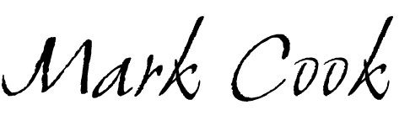
Sifu Mark Cook
6th Level Grand Master and Head of Three Family Fist.

