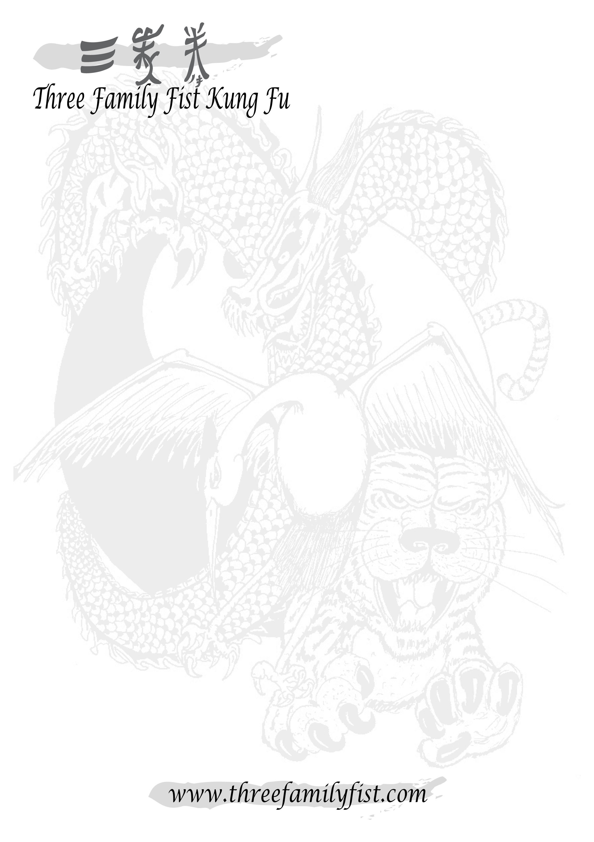
Dear Parent,
It is my pleasure to welcome you and your child to the Three Family Fist system or, if your child has been with us for some time now, to thank you for continuing to train in our style of Kung Fu.
As part of our ongoing commitment to being the region’s most cost-effective martial arts, I would like to take this opportunity to make you aware of the fees required to continue our high standards of fun, safe tuition for your child:
- Class fee: £4.00 per one hour session.
- Membership fee: £25.00 – this fee is paid yearly (or £3 per month, pro rata).
- Kung Fu suits: £35.00 for a black printed tee and satin, embroidered trousers.
(Garments are sold separately – Tee: £15.00, Trousers: £25.00)
PLEASE NOTE: Membership and a suit are required before a child can take his/her first grading.
- Grading fees: £15.00 for children White to Brown sash levels.
£20.00 for children Brown to Grey sash levels.
£75.00 for children’s first Black sash level.
Three Family Fist Kung Fu also have an extensive range of other merchandise, which is not a necessity to training. These range from practical products such as sparring kits, safe training weapons and sports bags to gift ideas such as other clothing garments, wallets and wrist bands. Please feel free to ask your Sifu for details or visit our website for a full product range.
Once again thank you for choosing Three Family Fist, I hope your child continues to enjoy his/her training and grow in confidence, strength and discipline.

Kind Regards,
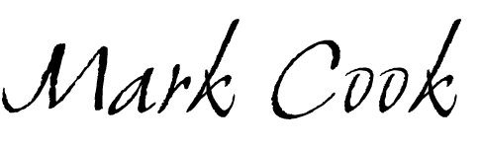
Sifu Mark Cook
6th Level Grand Master and Head of Three Family Fist.

